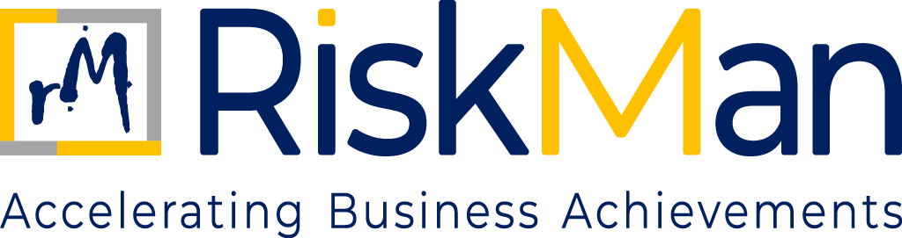
COMPLIANCE MANAGEMENT POLICY
TABLE OF CONTENTS
Compliance Management Policy

- Objective………………………………………………………………………………………………………………………….…….3
- Scope……………………………………………………………………………………………………………………………………..3
- Compliance Approach…………………………….………………………………………………………………………………3
- Compliance Governance Structure…………………………………………………………………………………………3
- Identification of Compliance Obligation… ……………………………………………………………………………..4
- Compliance Risk Assessment………………………………………………………………………………………………….4
- Policies, Procedure and Control…….……………………………………………………………………………………….4
- Monitoring and Compliance Review.……………………………………………………………………………………..5
- Reporting and Escalation.………………………………………………………………………………………………………5
- Regulatory Escalations…………………………………………………………………………………………………………..5
- Breach Management and Corrective Actions…………………………………………………………………………5
- Training and Awareness…………………………………………………………………………………………………………5

COMPLIANCE MANAGEMENT POLICY
- OBJECTIVE

The objective of this Compliance Management Policy (“Policy”) is to establish a structured and effective framework for ensuring that RiskMan Consulting LLP (“RiskMan” or “the Firm”) complies with all applicable laws, regulations, professional standards, and internal policies governing its business activities.
This Policy aims to:
- Promote a strong culture of compliance and ethical conduct
- Reduce regulatory, legal, and reputational risks
- Support informed and compliant decision-making
- Demonstrate the Firm’s commitment to regulatory and professional obligations.

- SCOPE

This policy applies to all individuals and entities associated with RiskMan Consulting LLP. It covers all employees, including those who are permanent, contractual, or interns, as well as partners, consultants, and associates who are professionally engaged with the Firm. Additionally, the policy extends to clients, suppliers, vendors, and any other third-party stakeholders who interact with or are connected to the operations and business activities of RiskMan in any capacity.

- COMPLIANCE APPROACH
RiskMan adopts a proactive, preventive, and risk-based approach to compliance management.
The Firm recognises that compliance is not limited to adherence to laws and regulations, but also includes:
- Compliance with professional standards
- Adherence to contractual obligations
- Observance of internal policies and procedures
- Alignment with ethical expectations of clients and stakeholders

- COMPLIANCE GOVERNANCE STRUCTURE
4.1 Oversight by Partners
The Partners have ultimate responsibility for:
- Approving the Compliance Management framework
- Overseeing material compliance risks and issues
- Ensuring adequate resources for effective compliance management

4.2 Management Responsibility
Senior management is responsible for:
- Implementing the Compliance Management framework
- Monitoring compliance within their areas of responsibility
- Escalating significant compliance matters to the Partners
4.3 Compliance Ownership
Specific compliance responsibilities may be assigned to designated individuals or functions, as determined by the Firm.
- IDENTIFICATION OF COMPLIANCE OBLIGATIONS
The Firm shall identify and maintain an understanding of its applicable compliance obligations, including but not limited to:
- Laws and regulations applicable to its business and operations
- Professional and ethical standards
- Contractual and client-specific requirements
- Internal policies and procedures
- Compliance obligations shall be reviewed periodically to reflect changes in the regulatory or business environment

- COMPLIANCE RISK ASSESSMENT
Compliance risks shall be assessed as part of the Firm’s overall risk management process, taking into account:
- The nature and complexity of the Firm’s activities
- Regulatory expectations
- Past compliance incidents
- Emerging regulatory developments
Material compliance risks shall be prioritised and addressed appropriately.
- POLICIES, PROCEDURES, AND CONTROLS
The Firm shall establish and maintain:
- Documented policies addressing key compliance areas
- Procedures to support consistent implementation of such policies
- Controls designed to prevent, detect, and respond to compliance breaches
Policies and procedures shall be communicated to relevant personnel and reviewed periodically.

- MONITORING AND COMPLIANCE REVIEWS
Compliance with applicable obligations and internal policies shall be monitored through:
- Ongoing supervisory activities
- Periodic internal reviews
- Issue tracking and follow-up mechanisms
Identified deficiencies shall be addressed in a timely manner
- REPORTING AND ESCALATION
Compliance issues, breaches, or suspected non-compliance shall be:
- Reported promptly through appropriate channels
- Escalated to senior management or Partners, depending on materiality
Material compliance matters shall be brought to the attention of the Partners without undue delay.
- REGULATORY INTERACTIONS
All interactions with regulators and authorities shall be:
- Conducted in a transparent, accurate, and timely manner
- Coordinated through designated personnel, where appropriate
Unauthorized or misleading communication with regulators is strictly prohibited.
- BREACH MANAGEMENT AND CORRECTIVE ACTION
Compliance breaches shall be:
- Investigated to determine root causes
- Addressed through corrective and preventive actions
- Documented appropriately
Where required, disciplinary action shall be taken in accordance with applicable policies.
- TRAINING AND AWARENESS
The Firm shall promote compliance awareness through:
- Induction programmes for new personnel
- periodic compliance training or communication initiatives, as appropriate
Training shall be tailored to the roles and responsibilities of personnel.

